THE LAWRENCE PUBLIC SCHOOL

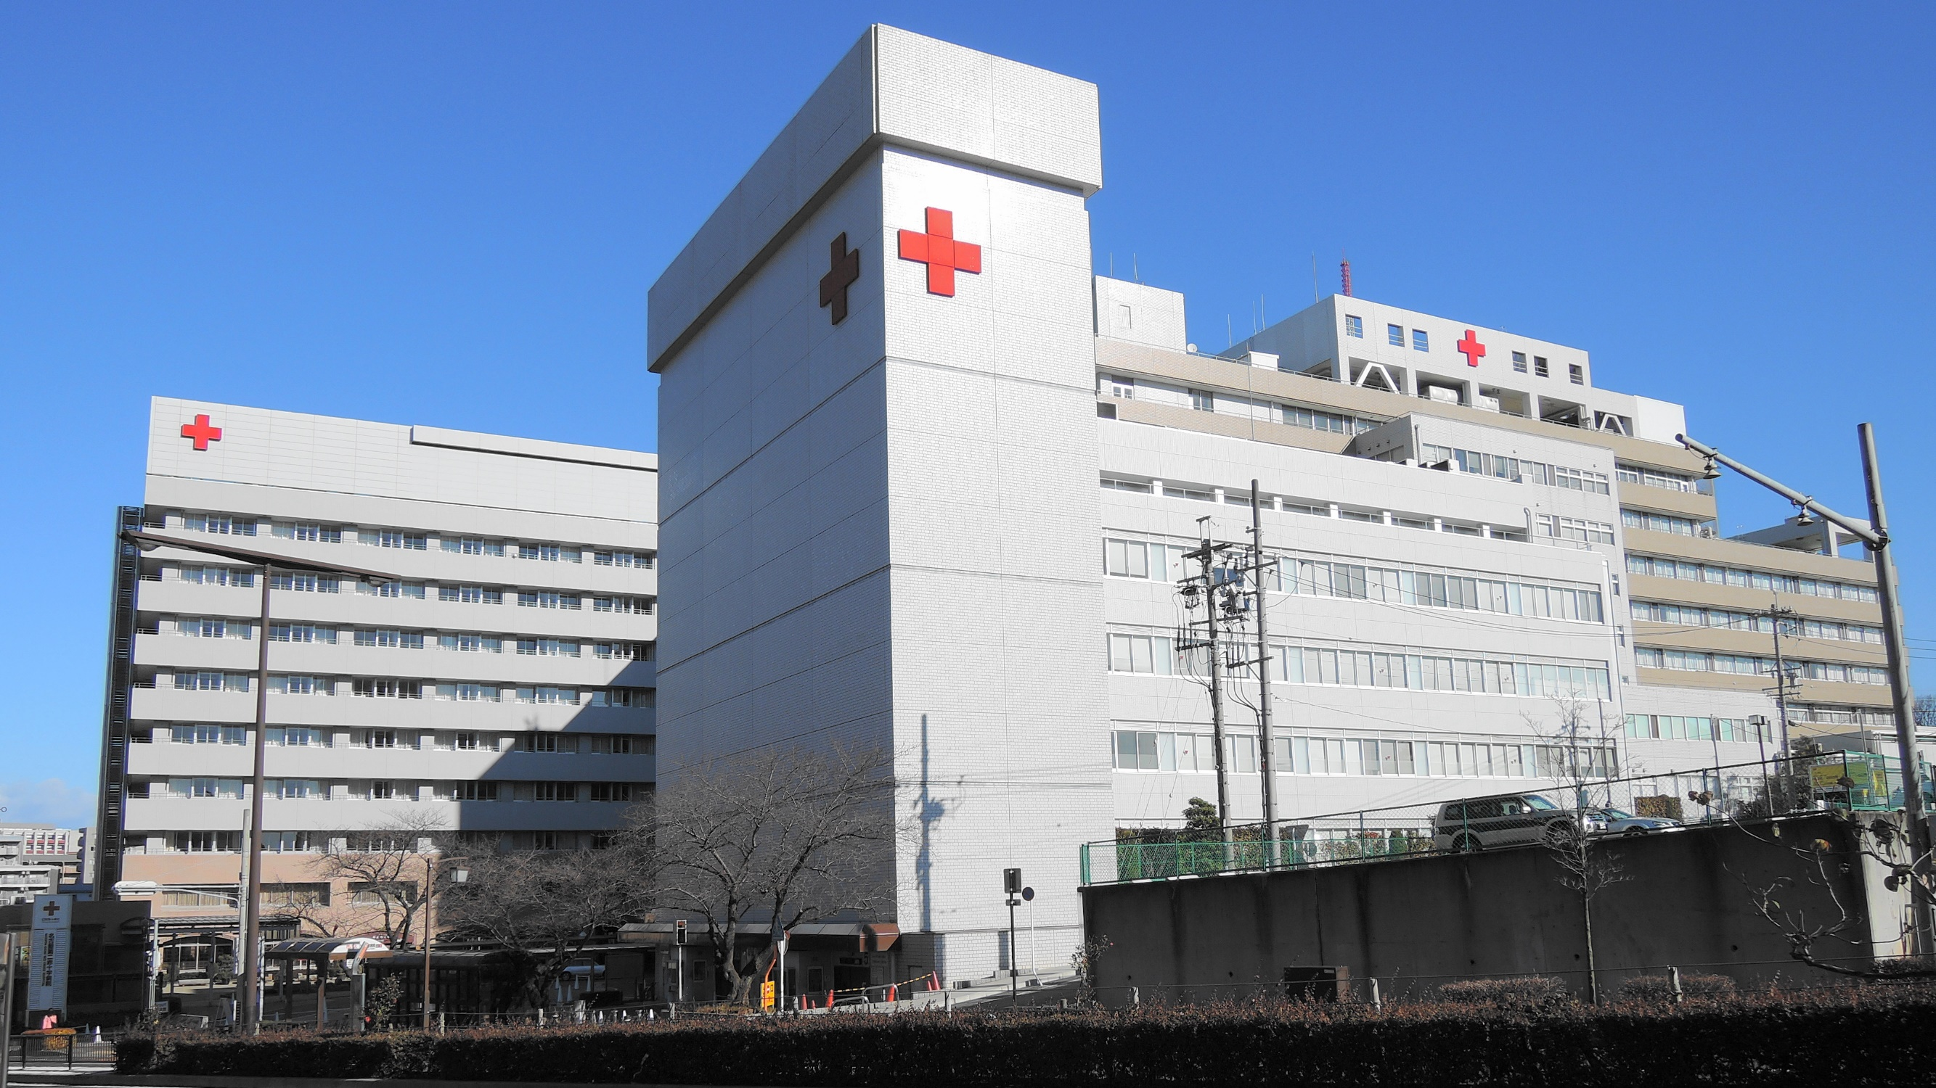 PROJECT ON HOSPITAL MANANGEMENT

SUBMITTED TO: SUBMITTED BY:
MRS. SUKHVINDER KAUR PARTH VERMA
P.G.T(Comp.SC.) XII - A

INDEX

- CERTIFICATE
- ACKNOWLEDGEMENT
- OBJECTIVE
- MODULES USED
- HARDWARE AND SOFTWARE REQUIRED
- TABLES USED
- SOURCE CODE
- OUTPUT
- BIBLIOGRAPHY

CERTIFICATE

This is to certify that Parth Verma of class XII-A of Lawrence Public School has done his project on “Hospital Management” under my supervision. He has taken interest and has shown at most sincerity in completion of this project. I certify this project up to my expectations and as per the guidelines issued by CBSE, New Delhi

Internal Examiner External Examiner
ACKNOWLEDGEMENT

It is with pleasure that I acknowledge my sincere gratitude to our teacher Mrs. Sukhvinder Kaur who taught and undertook the responsibility of teaching the subject Computer Science. I have been greatly benefited from her classes. I am especially indebted to our principal Mrs. Rekha Kumari who has always been a source of encouragement and support and without whose inspiration this project would not have been a successful. I would like to place on record heartfelt thanks to her. Finally, I would like to express my sincere appreciation for all the other students for my batch and their friendship and their fine times that we all shared together.

OBJECTIVE

City Hospital wants to computerise their hospital activities like admission of patients, recruiting new doctors, generating bill of patients, OPD, etc.

The project covers the following requirements:
- Stores the information of doctors working in the hospital also patients admitted in the hospital.
- Deletion, modification, and search for existing doctors and same for patients admitted.
- Generation, modification, deletion, and search for the bill of discharged patients.
- Displays, modifies, searches, and deletes the salaries of doctors.
- Generates reports of doctors with their salaries, patients, and their respective bill.
- Handles the tasks of OPD like storing, modifying and deletion.
HARDWARE AND SOFTWARE REQUIRED

Hardware:
- Keyboard
- Mouse
- 2 GB
- Processor Pentium 4

Software:
- Python IDLE
- MySQL 5.5.50

TABLES USED
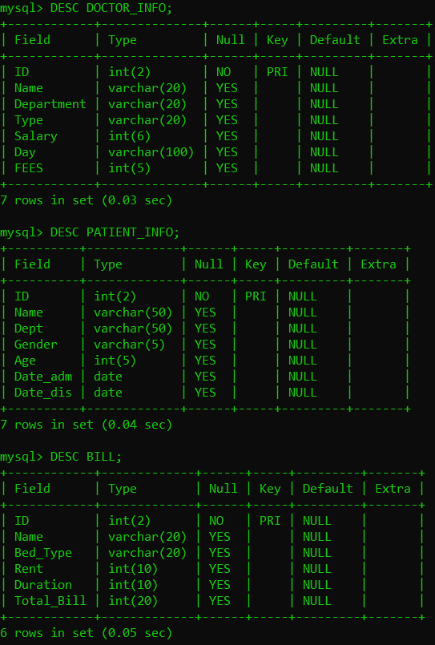
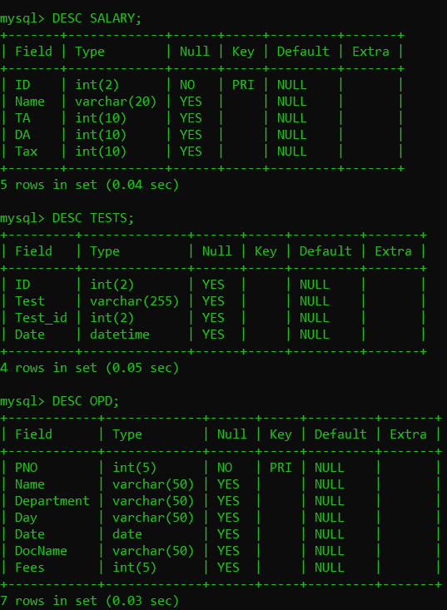

MODULES USED

- Doctor info
- Patient info
- Bill
- Salary
- Reports
- OPD
- Main menu
- Mysql.connector
- tabulate

******************SOURCE CODE
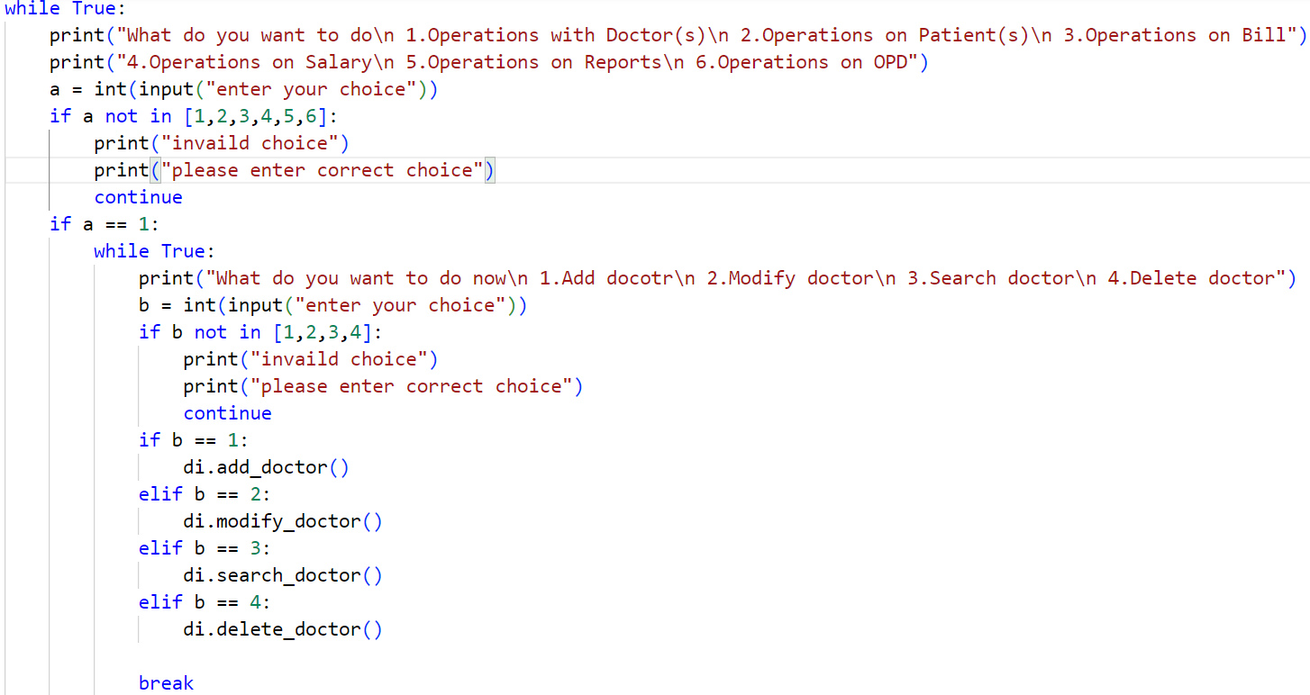
******************
MAIN MENU

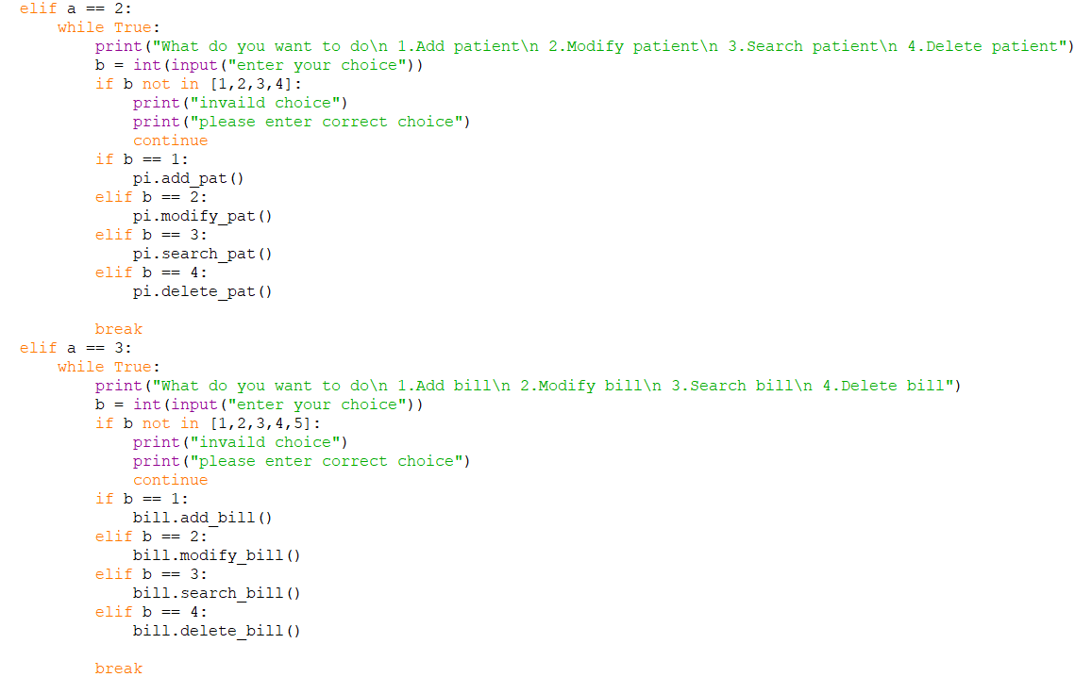
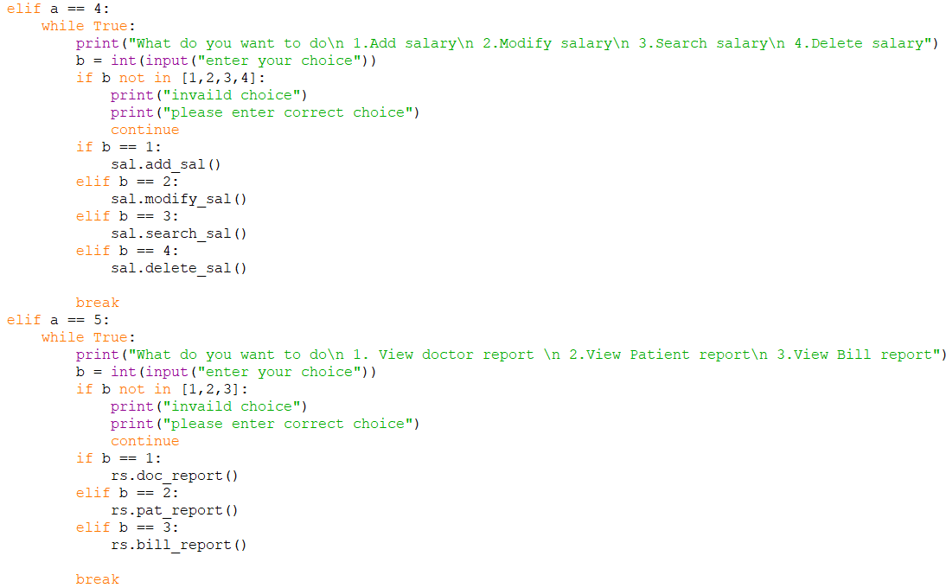
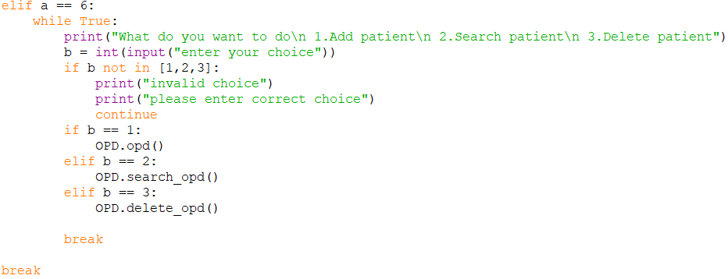
1.DOCTOR INFO MODULE
- ADD DOCTOR
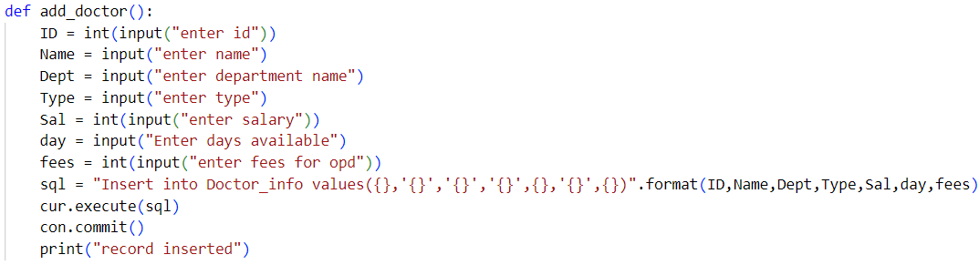
- SEARCH DOCTOR 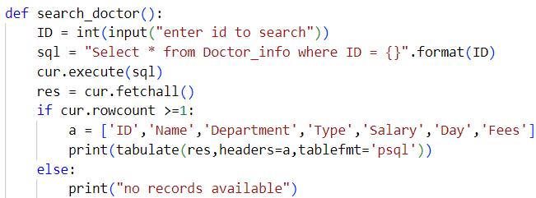
- MODIFY Doctor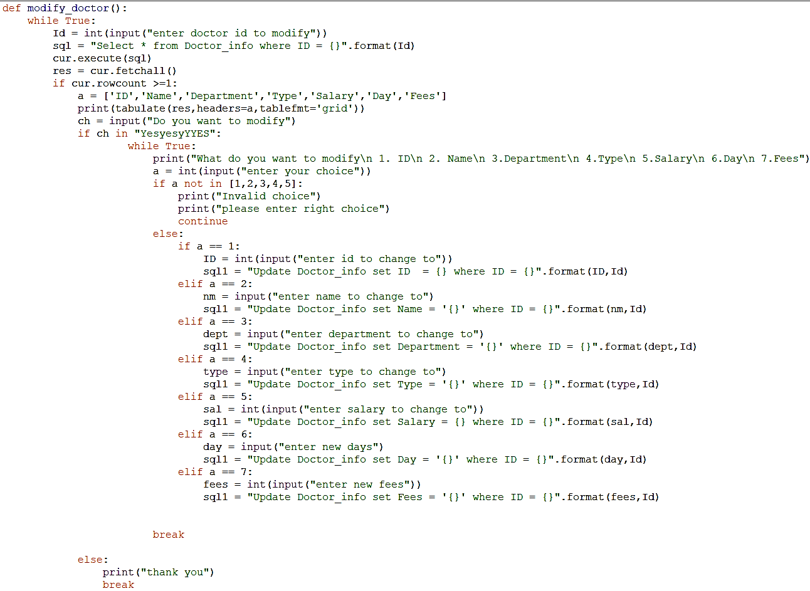
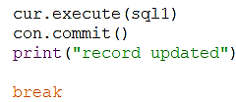
- DELETE DOCTOR
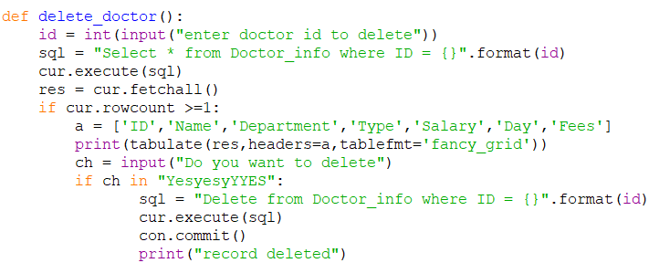

2. PATIENT INFO MODULE
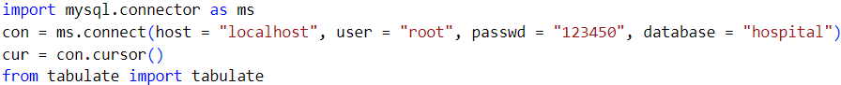
- ADD PATIENT
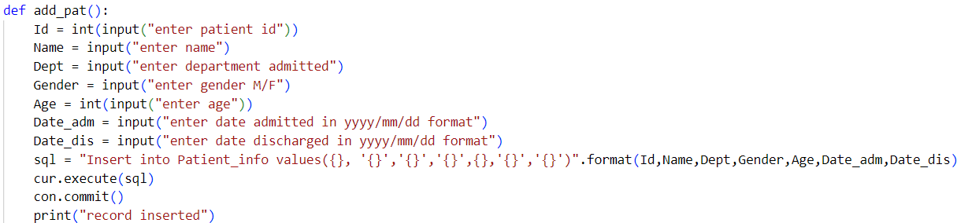

- MODIFY PATIENT
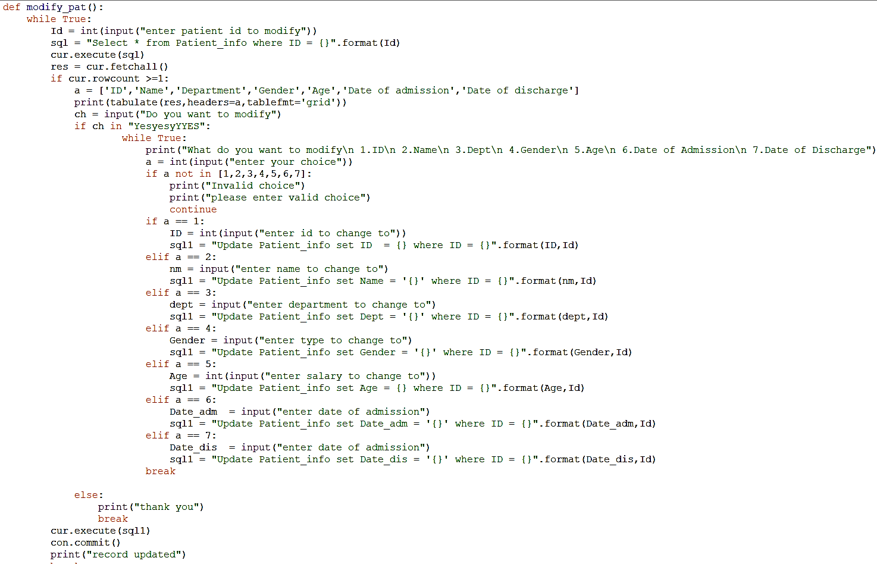

- SEARCH PATIENT
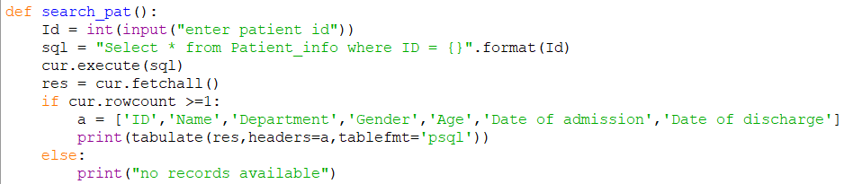
- DELETE PATIENT
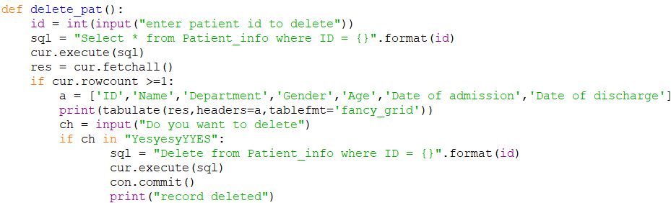

3. BILL MODULE
- ADD BILL
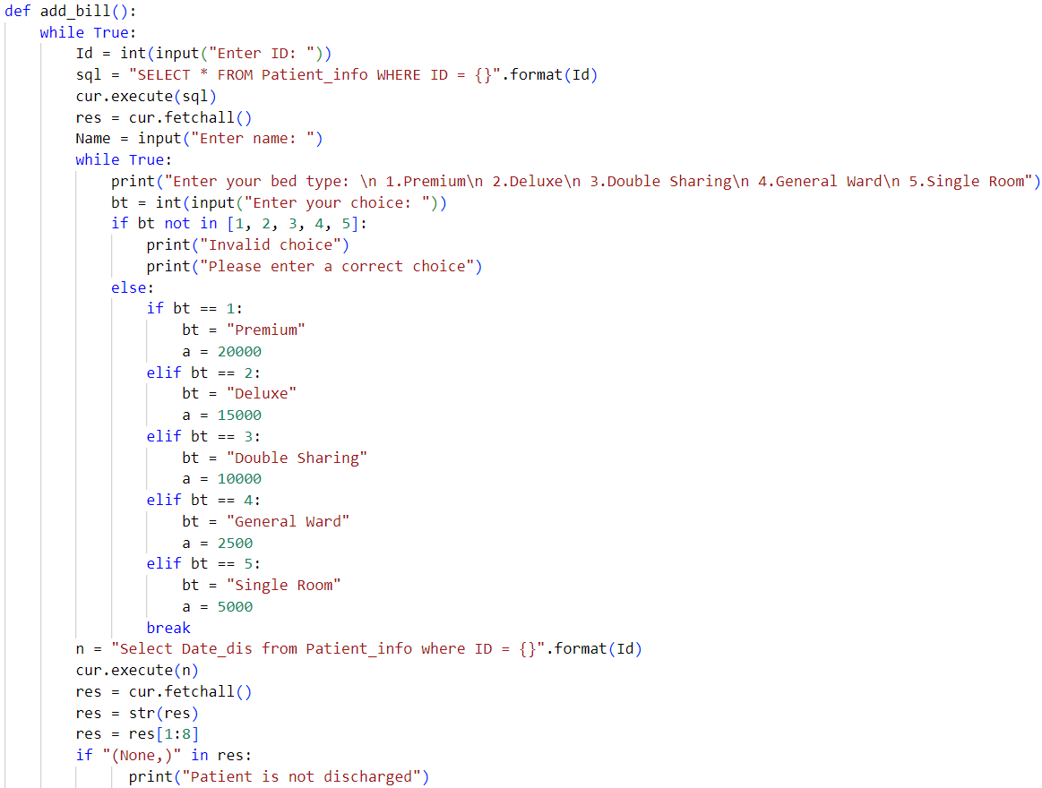
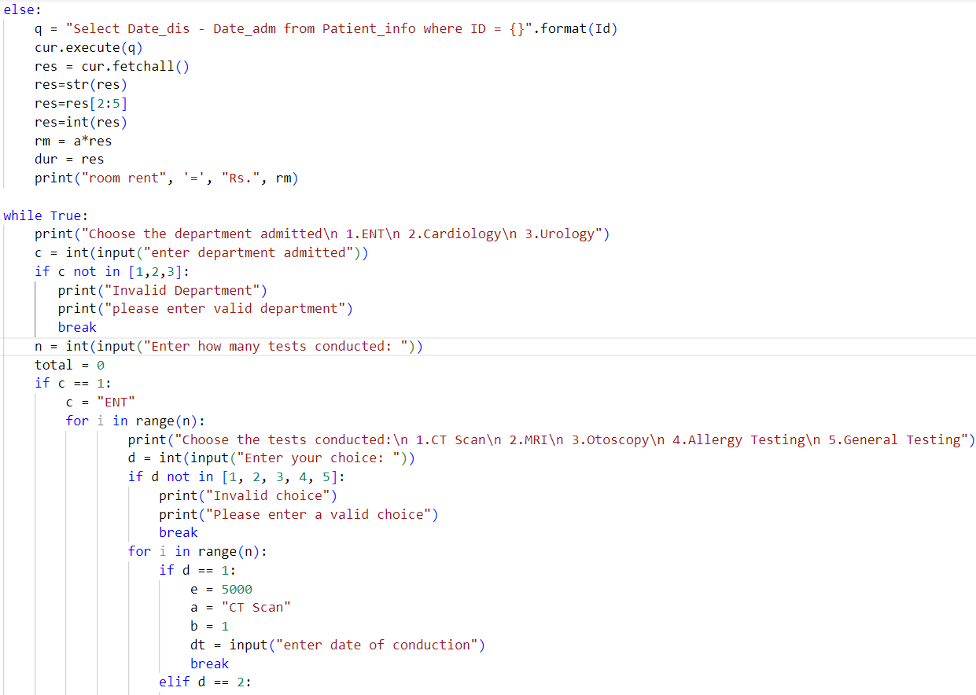

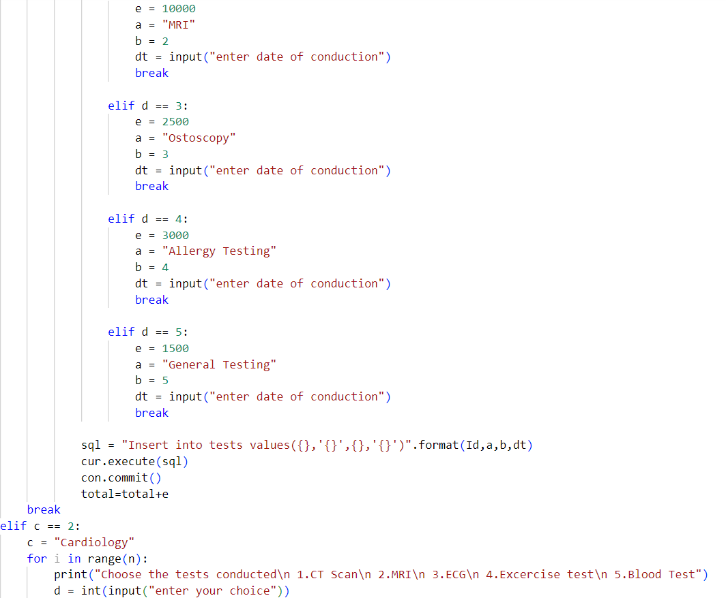
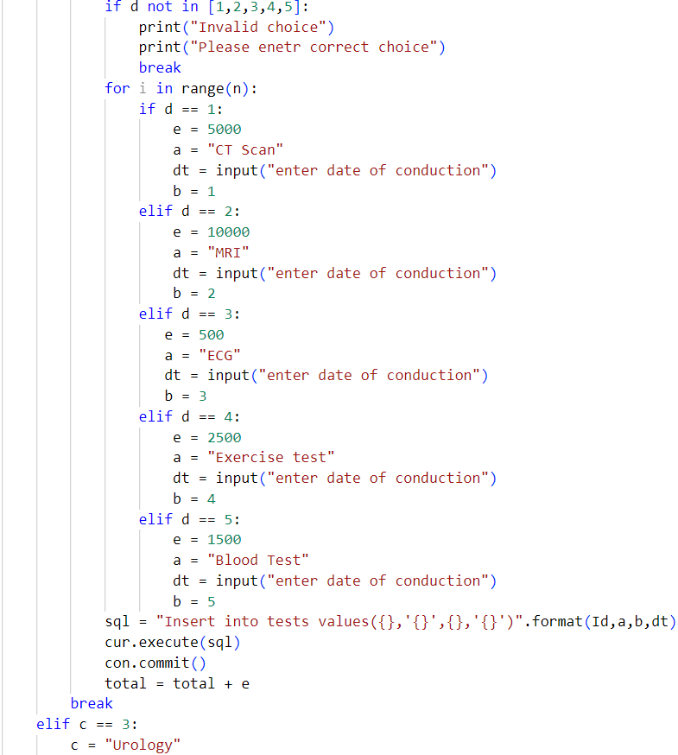
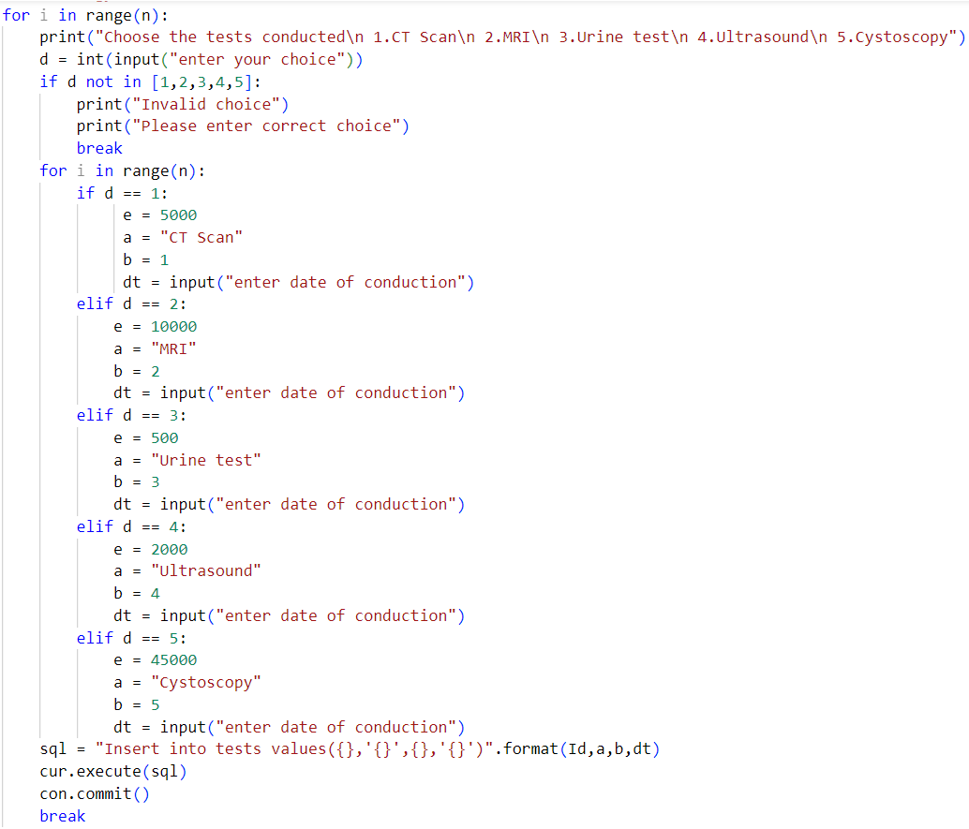
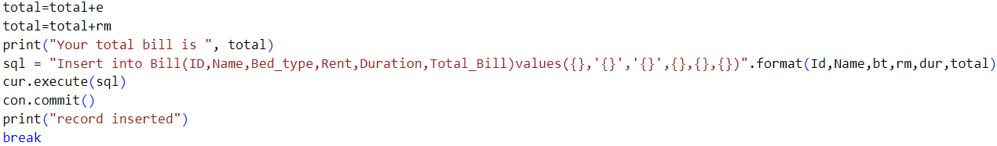
- SEARCH BILL
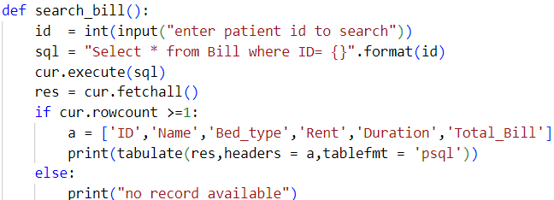

- MODIFY BILL
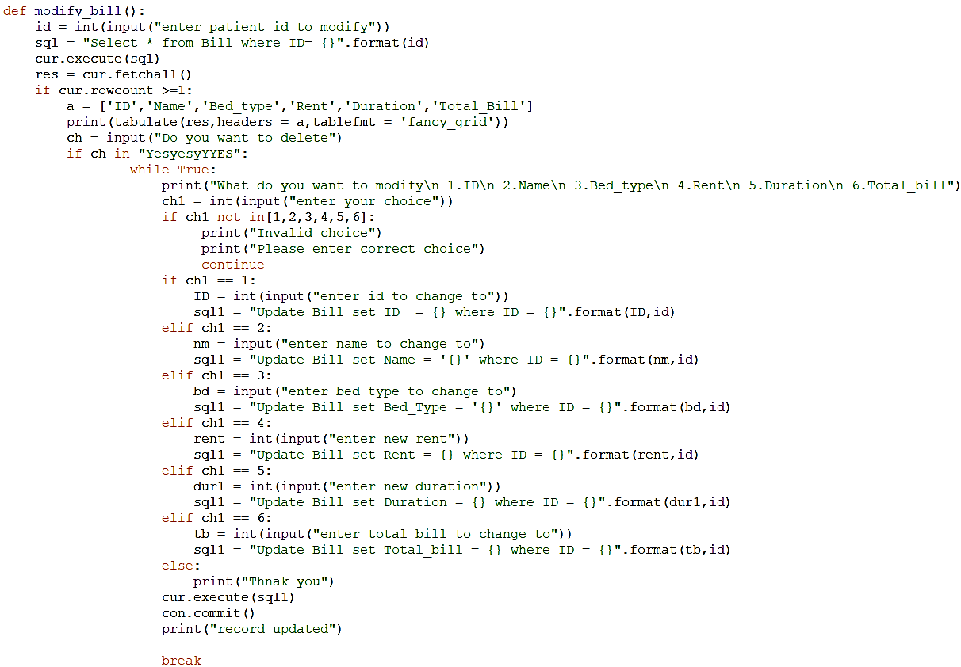

- DELETE BILL
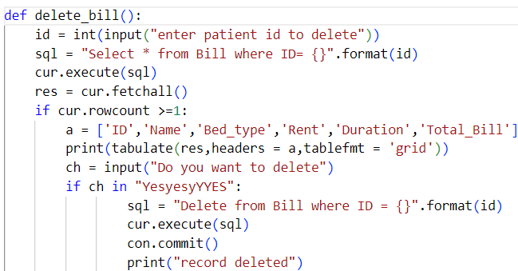

4.SALARY MODULE
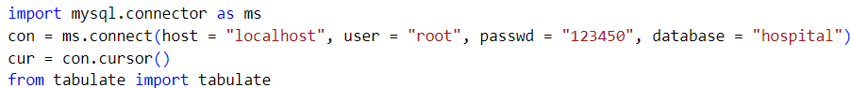
- ADD SALARY
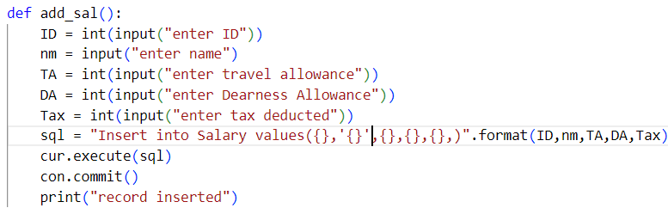
- SEARCH SALARY
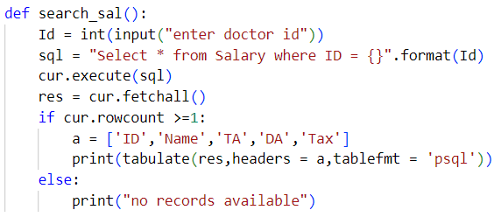

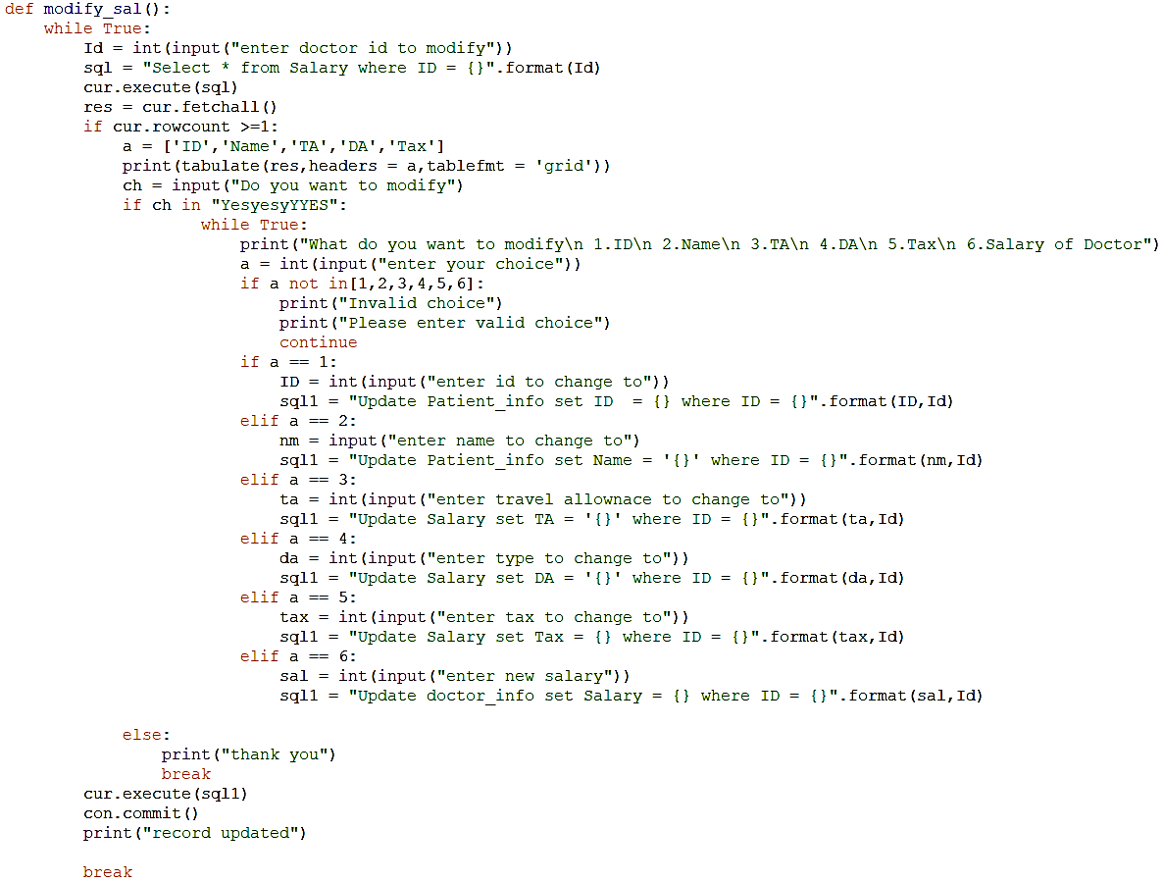
- MODIFY SALARY

- DELETE SALARY
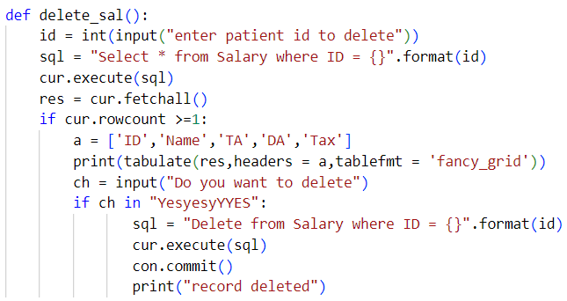

- Reports Module
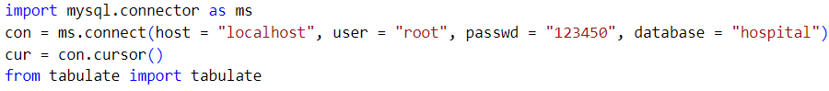
- VIEW DOCTORS REPORT
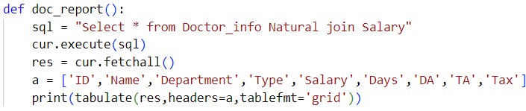
- VIEW PATIENT REPORT
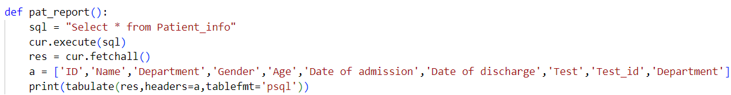
- VIEW BILL REPORT
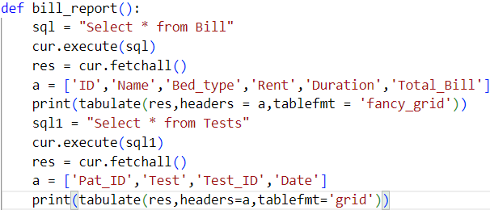

- OPD MODULE
- ADD PATIENT
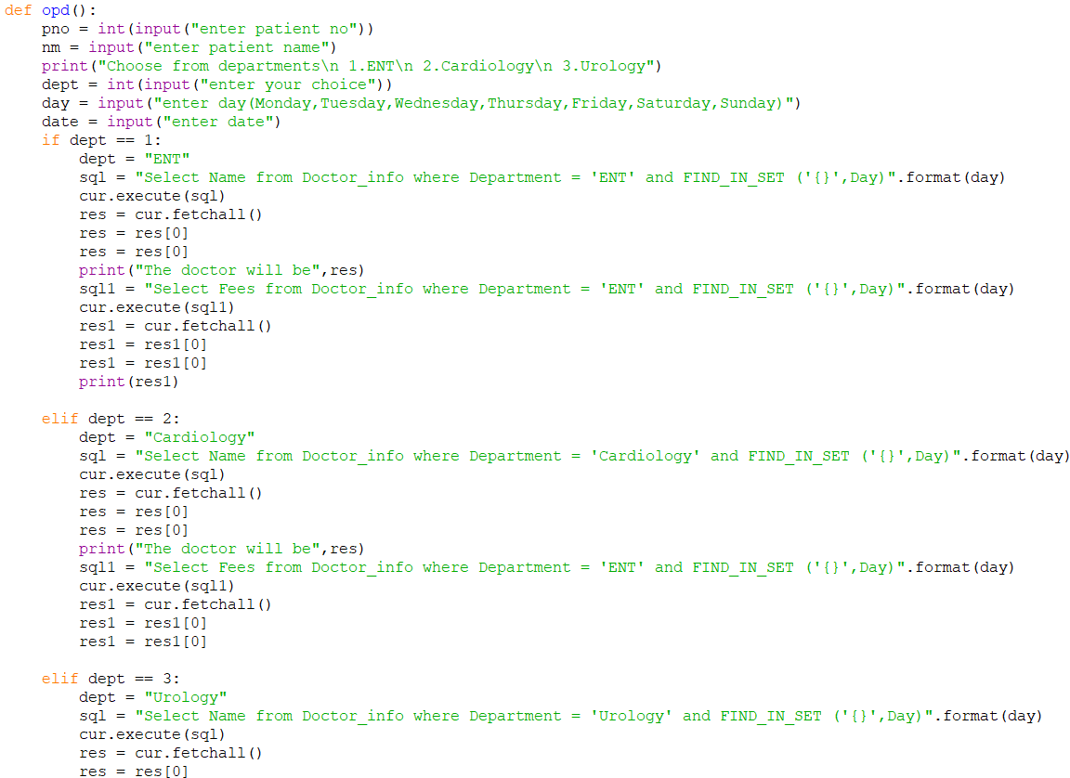
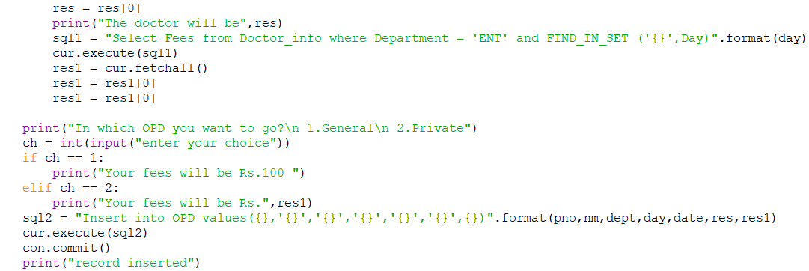
- Search patient
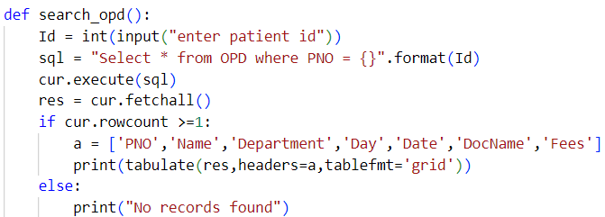

3.DELETE PATIENT
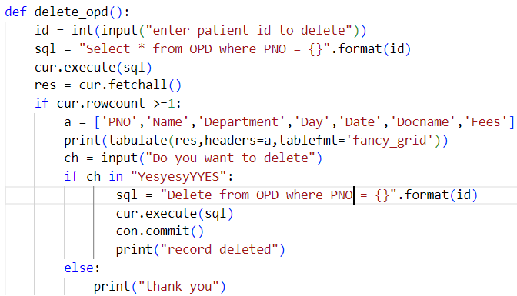

**************************
OUTPUTS
**************************

DOCTOR INFO OUTPUTS
- ADD DOCTOR
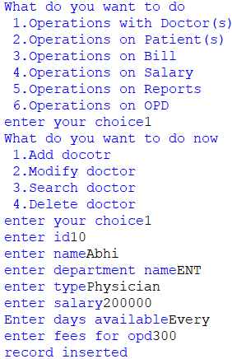

BEFORE
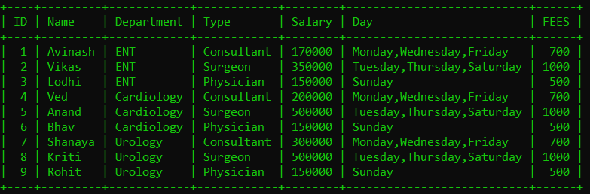
AFTER
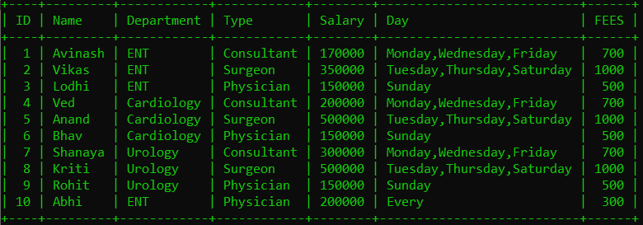

- MODIFY DOCTOR

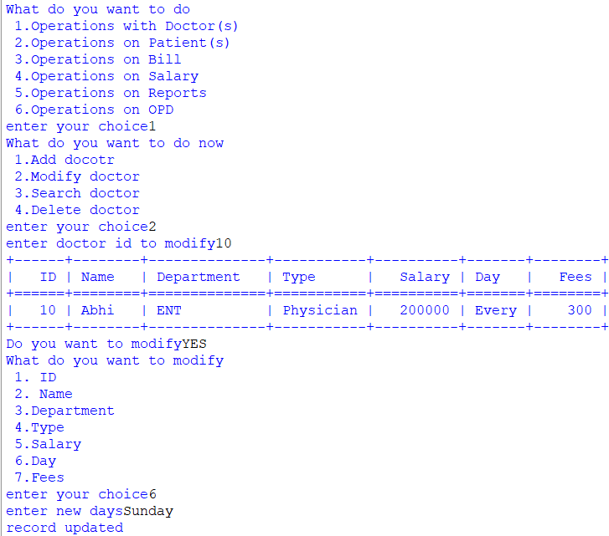

BEFORE
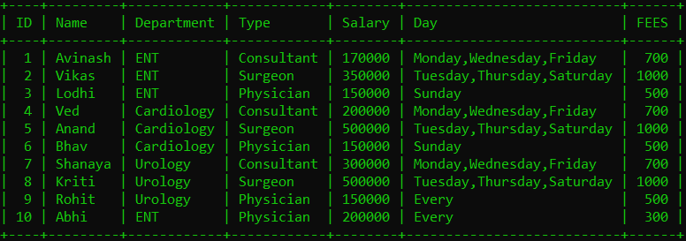
AFTER
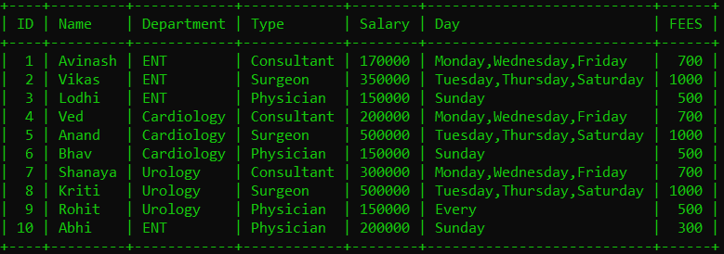

- SEARCH DOCTOR
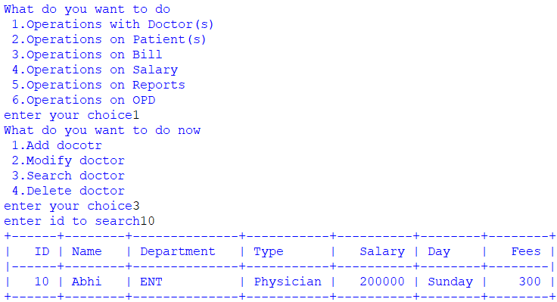

- DELETE DOCTOR
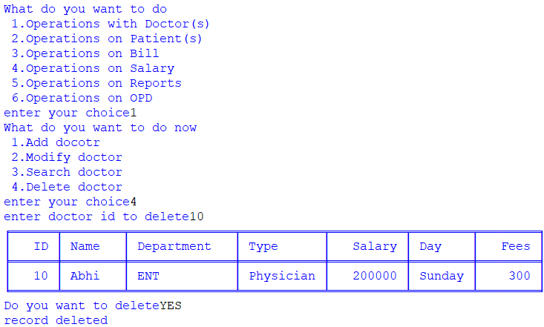

PATIENT INFO OUTPUTS
- ADD PATIENT
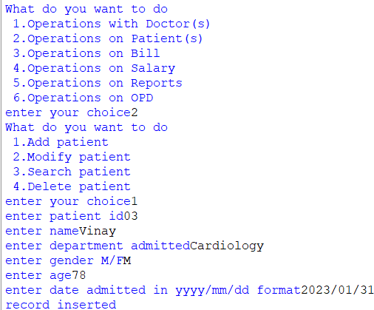
BEFORE
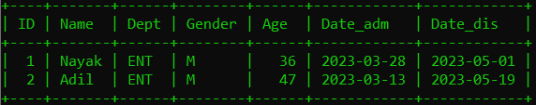AFTER
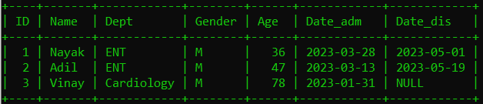

- MODIFY PATIENT
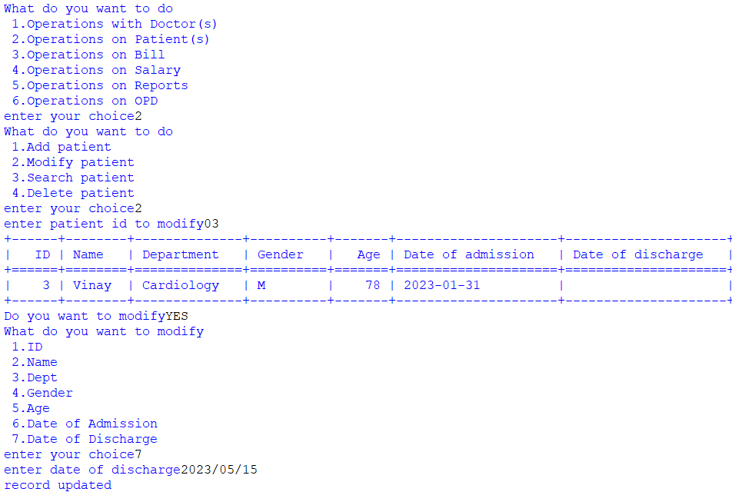
BEFORE
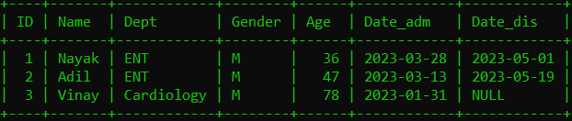
AFTER
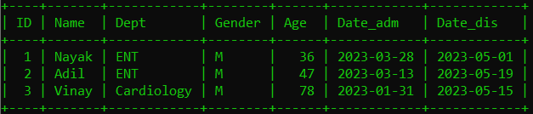
- SEARCH PATIENT
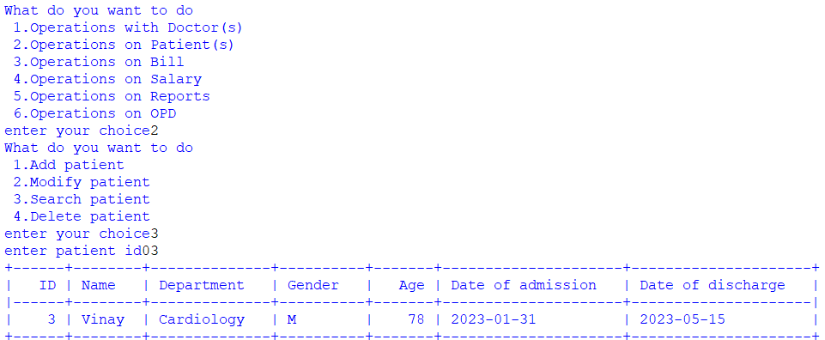

- DELETE PATIENT
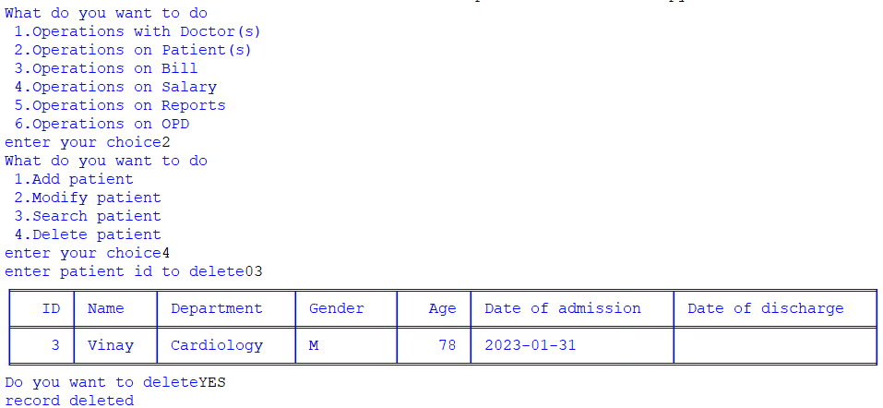
BEFORE
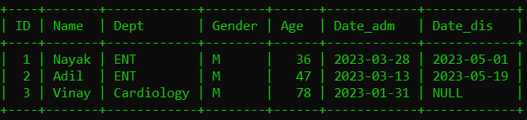
AFTER
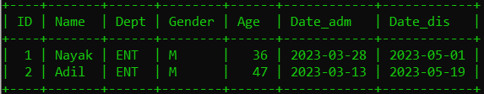

BILL MODULE OUTPUTS
- ADD BILL
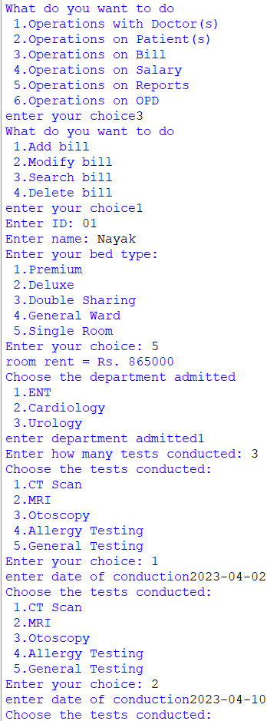
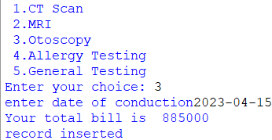
BEFORE
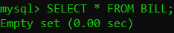
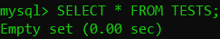
AFTER
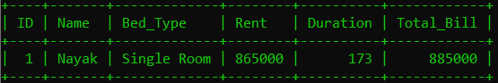
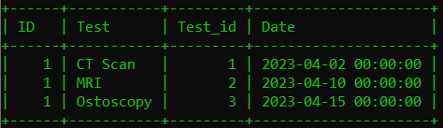

- SEARCH BILL
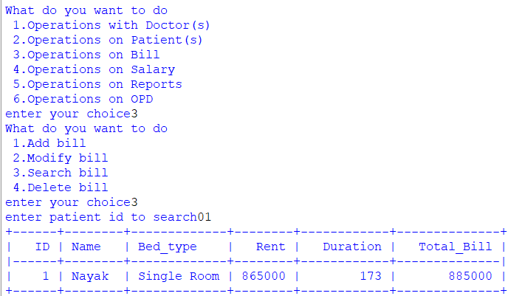
- MODIFY BILL
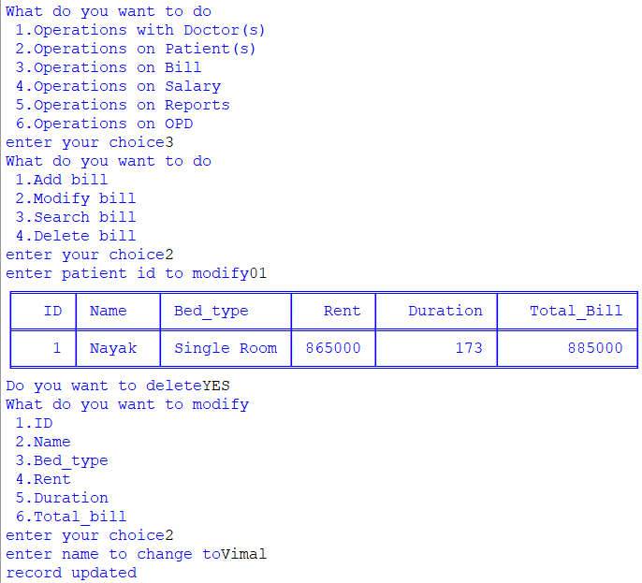
BEFORE

AFTER
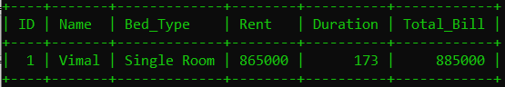

- DELETE BILL
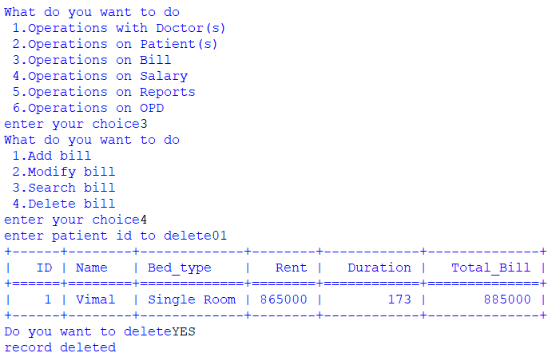

BEFORE

AFTER


SALARY MODULE OUTPUTS
- ADD SALARY
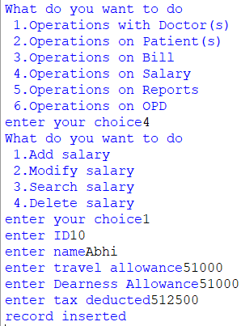
BEFORE
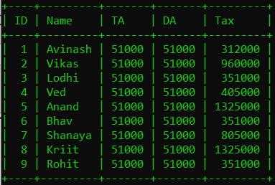

AFTER
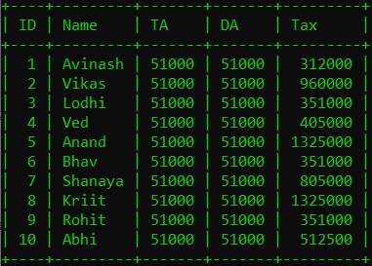

- MODIFY SALARY
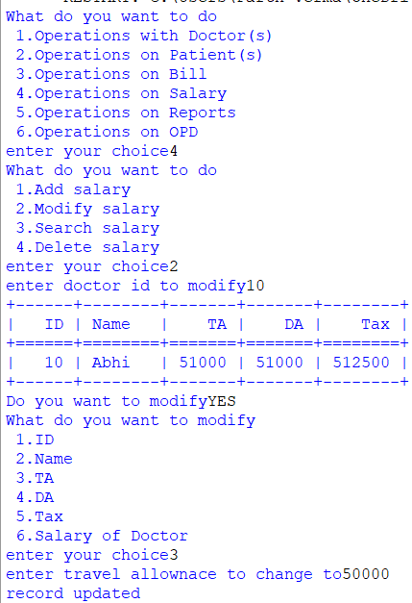

BEFORE

AFTER
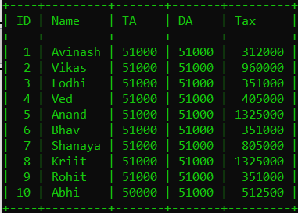

- SEARCH SALARY
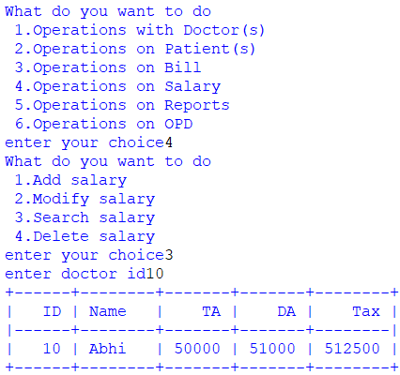
- DELETE SALARY
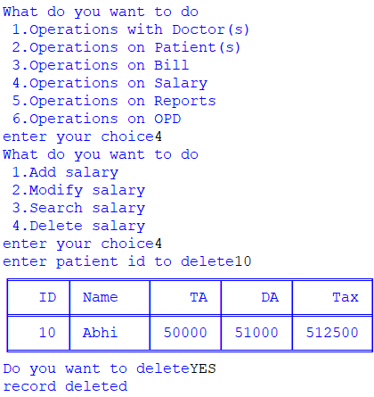
BEFORE

AFTER


REPORT MODULE OUTPUTS
- DOCTORS’ REPORT
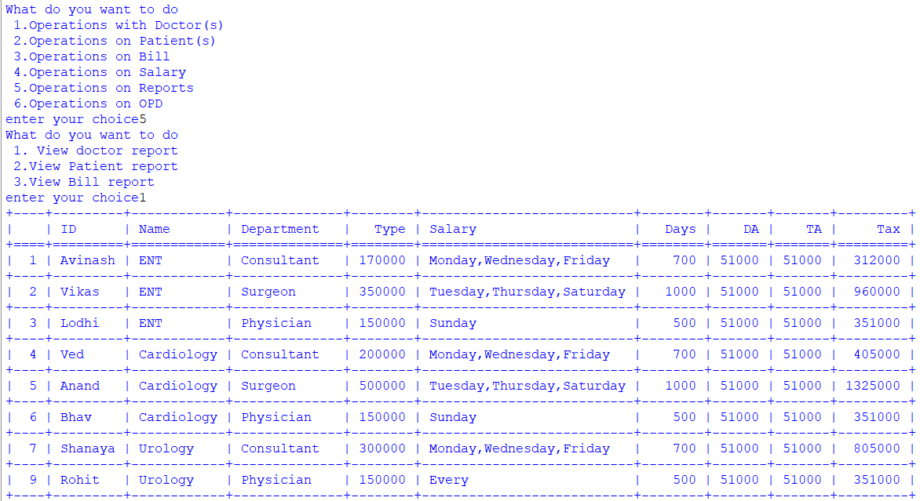
- PATIENT REPORT
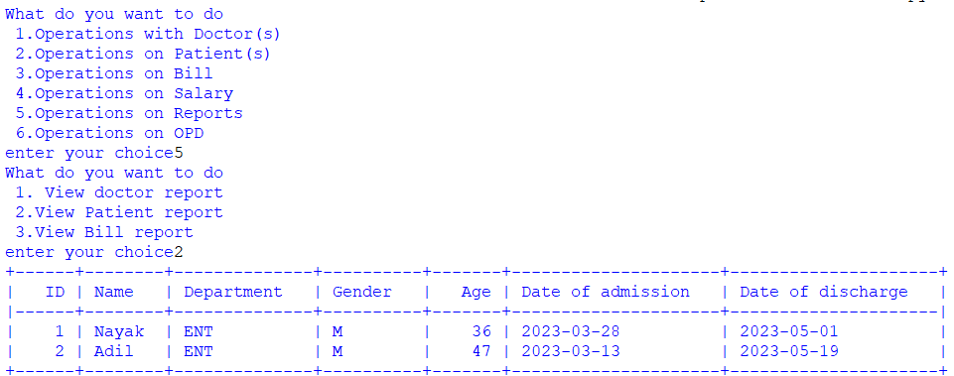

- Bill report
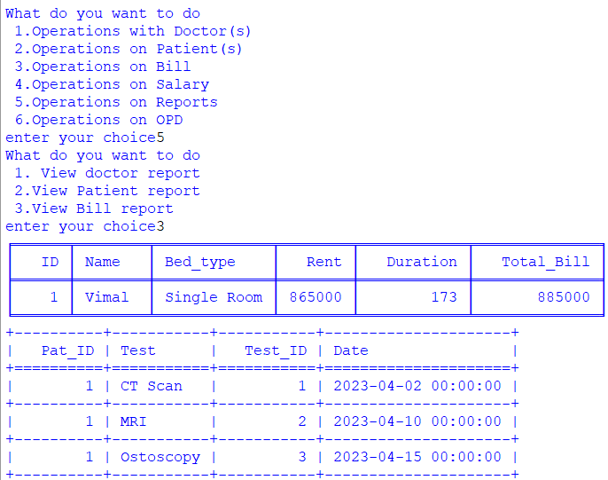

OPD MODULE OUTPUTS
- ADD PATIENT
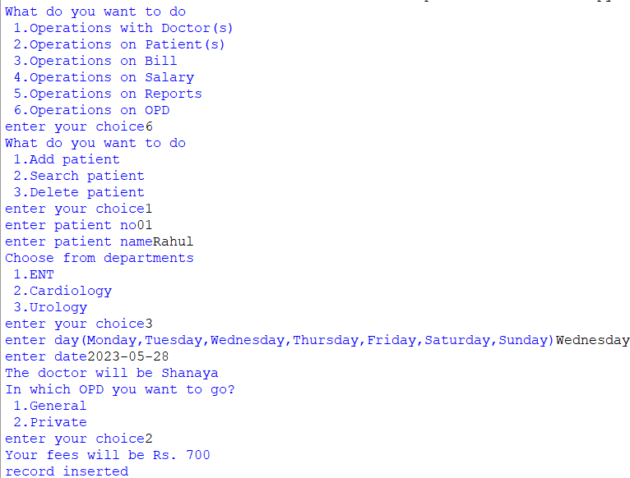
BEFORE
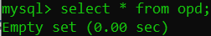
AFTER
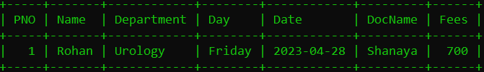
- SEARCH PATIENT
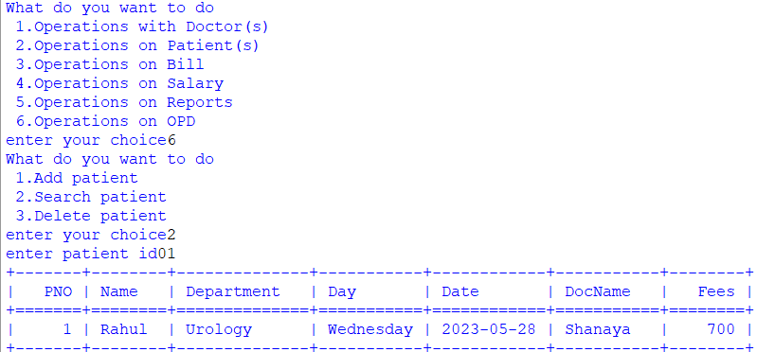
- DELETE PATIENT
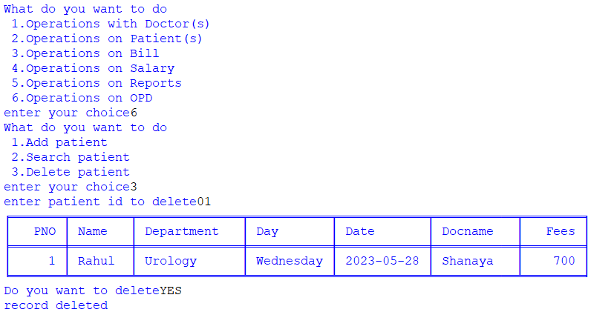
Before
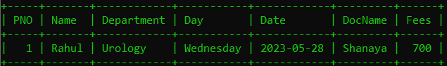
AFTER
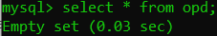
BIBLIOGRAPHY
C.S. with python(class-xii)
c.s. with python(class-xi)
https://pypi.org/project

